# **Starting a Business in Hospitality Post Covid**

Mark Buchbach

August, 2020

1. Introduction
   1. Background

With a large tourism sector and high per capita disposable income Queensland has supported a robust hospitality industry. The Covid-19 virus has caused significant damage to the industry directly and indirectly. The closing of Australia’s borders has reduced tourism dollars to a trickle which has reduced sales even in areas without any business restrictions. Areas that have had large numbers of cases have had severe restriction on the number of customers that can be served or even been forced to close down in the worst hit regions. This has led to many businesses to close down permanently.

1.2 Problem

The hospitality industry is a competitive one and often has low margins. The ability to predict which regions have the largest capacity to support new restaurants and bars as well as which types are currently being underserved in the area can provide a necessary edge in making a new business a success.

* 1. Interest

There are many chefs who desire to open their own restaurant but are understandably concerned about the feasibility of starting a new business in this economic climate. Being able to reduce the uncertainty over whether a market exists for their planned business and where that market exists will help encourage their investment leading to improvement in overall economic conditions.

1. Data
   1. Sources

The data on each area in Queensland has been compiled by Matthew Proctor which he has made available online [here](https://www.matthewproctor.com/full_australian_postcodes_qld). Information on venues in each area was sourced from Foursquare.

* 1. Data Processing

The location data contained information on several distinct region types. Non metropolitan areas were removed as Australia’s borders are still closed meaning that tourism is still minimal. Therefore, only areas with high population density will be evaluated for this project. Additionally, it contained several districts for each geographical location which were combined into individual rows.

Venue data was then extracted from Foursquare and assigned to each region. The venues were then grouped into broad venue types and normalized. At this point several areas had no venues within the radius used in the API call due to being more rural. These areas were removed from consideration as increasing the radius used would lead to too much overlap in the denser areas. Also due to smaller population density the regions would be less likely to be able to support as many venues in any case. Some venue types were removed from the data frame as they remain unused or underused due to the ongoing pandemic.

1. Methodology
   1. Clustering

The first step in determining the optimal conditions for opening a new hospitality location was to separate the regions of Brisbane into distinct clusters and then identify the properties of said clusters. K-Means was selected to perform this analysis which required a K value to be determined before clustering could be performed. This was done graphically using the elbow method which showed that the use of 4 clusters was the most appropriate option.

After assigning the K-Value a model was created using the venue data extracted from Foursquare which assigned the regions to one of the clusters. This was then used to generate a map of the region with each post code being represented by a marker coloured according to its assigned cluster (Fig 1).

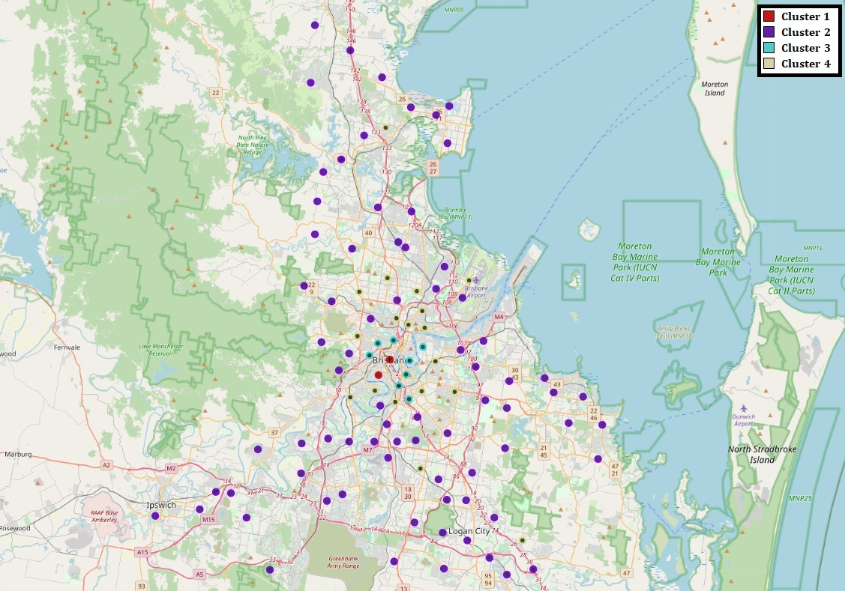

Figure 1 – Clustered Regions of Brisbane

* 1. Analysis of Venue Data

After the clustering was completed an examination of the venue data was conducted with respect to the clusters. Brisbane wide totals were calculated for each type of venue in order to determine which types of venue are sufficiently popular in the city to be prime candidates to open. Mean venue numbers were calculated for each region in order to determine which areas were underserved in particular venue types show which venues would lack competition in an area.

1. Results
   1. Analysis of Clusters

Analysing the venue data for each cluster showed that the K-Means algorithm clustered each region based on the density of hospitality venues in that area. Cluster 1 was assigned to only two regions the inner city and West End and Cluster 3 was assigned to the areas immediately surrounding them. These areas are high density areas of multi-storey apartments and demographically populated with young professionals who have high levels of disposable income and are statistically the most active socially. These factors allow the regions to support the highest number of hospitality venues.

The saturation of hospitality venues is much lower in Cluster 2 as these areas are comprised of suburban, rural, commercial and industrial areas. The fourth cluster lies between Cluster 2 and Cluster 3 in terms of venue density. It is comprised of two distinct types of region the first being a ring of inner suburbs surrounding Cluster 3 with smaller apartment buildings and townhouses. The other type are higher density nodes in the satellite towns around Brisbane providing hubs to service the surrounding areas.

* 1. Region Selection

From the data collected regions that fell in Cluster 2 are limited in their ability to support large numbers of venues and were excluded from further analysis. As they have demonstrated the greatest ability to support bars and restaurants both Cluster 1 regions were kept for further study. From Cluster 3 two regions were retained: Greenslopes/Stones Corner (4120) and Balmoral/Bulimba (4171). These two were selected as they are isolated from the central hospitality blob by the Brisbane River as well as having less dense areas on their outskirts that venues they host can service. Only the second type of region was included from Cluster 4 as while the population density is lower than in the central blob they are sufficiently distant that the areas surrounding them are lacking in variety making them prime candidates to open a new business as they have a captive customer base as well as having lower rent costs. The three regions included from Cluster 4 were: North Lakes (4509), Shailer Park (4128) and Sunnybank (4109).

* 1. Venue Selection

The selection of the top 10 venue types in Brisbane was used to determine how prevalent each of these types were in the regions chosen for analysis (table 1).

Table 1 – Number of Venues per Region

|  |  |  |  |  |  |  |  |  |  |  |
| --- | --- | --- | --- | --- | --- | --- | --- | --- | --- | --- |
| **Post Code** | **Cafés** | **Fast Food** | **Pizza** | **Bars** | **Pubs** | **Subs** | **Sushi** | **Bakeries** | **Thai** | **Burgers** |
| 4000 | 34 | 0 | 1 | 21 | 8 | 0 | 4 | 1 | 5 | 9 |
| 4101 | 28 | 0 | 2 | 9 | 7 | 2 | 0 | 1 | 4 | 7 |
| 4109 | 3 | 3 | 2 | 0 | 1 | 1 | 3 | 0 | 1 | 1 |
| 4120 | 19 | 4 | 1 | 1 | 2 | 2 | 3 | 0 | 2 | 2 |
| 4128 | 3 | 6 | 2 | 0 | 1 | 2 | 2 | 0 | 1 | 0 |
| 4171 | 15 | 0 | 3 | 1 | 1 | 1 | 2 | 2 | 2 | 2 |
| 4509 | 5 | 4 | 2 | 0 | 3 | 2 | 2 | 0 | 0 | 0 |
| **Total** | **107** | **17** | **13** | **32** | **23** | **10** | **16** | **4** | **15** | **21** |

Certain of these types while common over the city as a whole were underrepresented in some regions e.g fast food restaurants in the city and West End. In some cases this is likely due to a mismatch between the type of venue and the region. In order to determine whether this is the case mean values for each cluster were calculated for comparison (table 2).

Table – Average Venues per cluster type

|  |  |  |  |  |  |  |  |  |  |  |
| --- | --- | --- | --- | --- | --- | --- | --- | --- | --- | --- |
| **Cluster** | **Cafes** | **Fast Food** | **Pizza** | **Bars** | **Pubs** | **Subs** | **Sushi** | **Bakeries** | **Thai** | **Burgers** |
| 1 | 31.000 | 0.000 | 1.500 | 15.000 | 7.500 | 1.000 | 2.000 | 1.000 | 4.500 | 8.000 |
| 3 | 18.250 | 1.500 | 2.625 | 4.125 | 3.125 | 2.750 | 2.375 | 2.375 | 2.750 | 3.750 |
| 4 | 7.833 | 2.833 | 2.167 | 1.056 | 1.444 | 1.889 | 2.444 | 1.722 | 1.667 | 0.889 |
| **All** | **12.464** | **2.250** | **2.250** | **2.929** | **2.357** | **2.071** | **2.393** | **1.857** | **2.179** | **2.214** |

Comparing the venue count in each region with the mean for that cluster type showed some regions to be particularly underserved by particular venues. Cluster 1 venues were close to their means meaning that while overall demand in the areas is high most venue types are likely at or near saturation. The Cluster 3 regions were significantly below average for bars, pubs, and burger joints. In addition, Greenslopes has no bakeries in the area. The three Cluster 4 regions were short cafes, bakeries and Thai restaurants.

1. Discussion

While the Cluster 1 regions may have the highest overall demand the high price of rent in the areas as well as the already significant supply makes them less enticing for opening further competition. While Greenslopes does lack a dedicated bakery, supermarkets in the area will have their own internal bakeries so while it is likely still a good place to open a bakery it is not as good as it first appears. The opening of burger joints in Greenslopes and Bulimba would also be appropriate as both regions are underserved. Much like Greenslopes the Cluster 4 regions were low on bakeries and would be acceptable places to open new ones. They would also be good places to open Thai restaurants. The overall best place and venue combination to open from this analysis are cafes in North Lakes, Shailer Park and Sunnybank. Cafes are by far the most popular venues in Brisbane with more than two times as many in operation as their closest rival. All 3 areas were significantly lower than the average for their cluster with Shailer Park and Sunnybank having less than half the average.

1. Conclusion

While this analysis took into account the supply and demand of hospitality services in the Brisbane region it did not take into account other factors including available transportation and other factors such as costs were limited in scope. In addition, while the analysis is appropriate for the current moment it does not take into account other developments in the city. The completion of a new university campus on the north side is likely to provide further opportunities in the area in order to service the students and faculty.